YLDP 2011-12 Inaugural sessionswith Judge Ravi K. Sandill
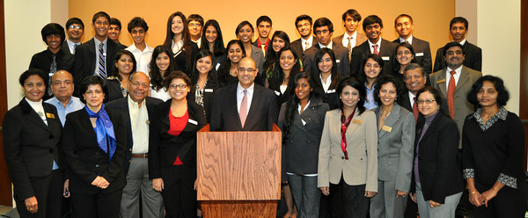
On October 29, 2011, the inaugural session for the Youth Leadership Development Program of Houston took place at the India House. Thirty one future Indo-American leaders, all high school juniors and seniors, were inducted into the program by the YLDP Board of Directors. Honorable Judge Ravi K. Sandill was the keynote speaker of this event.
Judge Sandill enlightened the students with the story of his journey as an Indo-American leader. He grew up in a military family, traveling around the world, from Toronto, to Cambridge, to Austin. As a student at UT, Judge Sandill spent a summer at Capitol Hill working as an intern in the White House Council of Economic Advisors. He completed his law studies at the University of Houston. Three months after he began his law practice, Judge Sandill was diagnosed with Hodgkin’s lymphoma. Despite battling cancer, Judge Sandill took advantage of an opportunity to run for an elected office when one was presented to him and was elected the judge of the 127th District Court in 2008. He explained that “opportunity doesn’t usually call twice” while emphasizing that “opportunities do require commitment to realize.” “Life is short”, Judge Sandill said, “So take the opportunity to grow yourself”. To realize his personal dream, he and his wife, Kelly, also decided to adopt their son, Asher, from Guatemala later that year.
Following the speech, the students were given the opportunity to present their reflections. It was clear to see how much the students were inspired by his leadership qualities. He taught them the importance of optimism, determination, and resourcefulness. His story inspired them to change their outlook on challenges by striving to overcome them, rather than succumb to them. His message to the YLDP students was to be led by their dreams, and to turn perceived problems into opportunities

YLDP students Anuva Kachra, Avanthika Gopal, Deep Patel, Navin Kalluri, Priya Bhattacharjee, Srimahesh Vangavolu, Raj Kavadi, Natasha Kumar, Sanjiv Gopalkrishan, and Shourya Saxena contributed to this report

